**Fig Tree Care**

The figs you have purchased can be grown in pots or outdoors since they are hardy varieties. Pot the trees for the first year. The older they are the hardier they become. They can be planted outdoors in areas where temperatures do not go below -13 °C (12°F). In Canada that only occurs in parts of BC. For the rest of us either pot the trees, plant them in a cool temperature greenhouse or winter protect them in the ground. We will cover all these methods here. We will start with potted trees.

**Potting Instructions**: Any good potting mix may be used, but we suggest using a lightweight mix if you are going to move the plant around in a large pot or tub. 18–24-inch pots, or half-barrel size tubs, can be used as the ultimate pot size. A caster cart is handy for moving the trees around. A smaller 12-inch pot can be used to begin with; however, it will eventually restrict the tree’s growth. Be sure that your container has drainage holes. A good potting mix to use would include about 1/3 of each, shredded bark, peat moss, and perlite with the possible addition of well-rotted compost. These materials allow for good drainage, are light weight, and yet they have good moisture holding capacity. Figs respond well to calcium (bone meal), so it is a good thing to add to the soil mix. Use about 2 tbs. per gallon of soil mix.

During the summer water potted trees twice weekly with the recommended rate of water-soluble fertilizer for house plants such as Peters 20-20-20 fertilizer or Osmocote 8–9-month time release fertilizer. During hot weather or if the leaves are drooping, water immediately. Add water until it shows water coming out of the drainage holes in the pot. As the figs ripen do not allow the plant to dry out excessively as this could cause the figs to shrivel.

Potted figs should be moved **indoors** for winter protection. The above ground roots cannot stand freezing temperatures even though the tops of the trees are hardy enough. They need a dormant period to restore energy. They can be stored after the leaves have fallen. Place them in an insulated garage, temperature controlled shed, cool fruit cellar, low temperature greenhouse, or a plywood enclosure that can be assembled and removed annually. The temperature should be below 50°F. (10°C) but not below freezing for periods of more than a day at a time. Figs are normally drought tolerant but should be checked periodically for dryness in storage. Do not overwater in storage.

To create a worry-free winter condition, a temperature-controlled environment can be created with a heat lamp pointed at the roots and a temperature-controlled thermostat like the TC3 Thermo Cube pictured here. Plug it into a wall outlet, extension cord or power bar. Then plug the heating unit into it. Place the thermostat close to the trees. The pre-set thermostat in this case is set to turn on at 5°C (40°F) and off at 8°C (45°F). To save energy, wrap the tree(s) with a plastic tarp and include a 60 watt incandescent bulb under an aluminum dryer tube to more evenly distribute the heat. Include the Thermo Cube inside to control the temperature. If you have the old-style Christmas lights, wrap them around the pot and turn them on with the Thermo Cube as an alternative. Thermo Cubes can be purchased online at reasonable prices.

In early spring, you may give the trees an early start by bringing the potted tree into a warm sunny room to speed up the time it takes time to leaf out. It can be moved back outside when all danger of frost has passed. It is possible to get two crops in one season on some figs by extending the growing season in this way. If the crop has not finished ripening in time, the plant can be brought in early before frost and leaf drop, to finish ripening the crop.

An alternative method, which makes the figs less dependent on your watering, is to plant the entire potted fig, pot and all, 15 cm into the ground. The fig will send roots through the bottom drain holes of the pot, grow vigorously and fruit abundantly. When the leaves fall in the autumn, dig up the potted fig tree, cutting off the ground roots. Store the fig indoors and plant the same way again the next year. This method requires less water and fertilizer, especially if the pot is mulched.

**Planting Fig Trees in the Ground**

Planting the fig trees in the ground is the easiest way to grow them, except for winter protection. Figs have few issues. They don’t need spraying and the only insect problem is ants that climb into the trees when the fruit is ripening and enter the eye at the end of the fruit, spoiling it. This can be prevented by putting wood ash around the trunk or a sticky substance like Tanglefoot that traps them. Low branches need to be removed and other ways for the ants climb into the trees. Most of our fig cultivars have small or closed eyes that do not attract the ants.

If you live in an area where summer frosts or cool nights often occur, you will need to protect your trees. This would likely be in colder zones 3-4. In those zones the best way to protect the trees is to plant them in a greenhouse or pot them and keep them indoors in a sunny area.

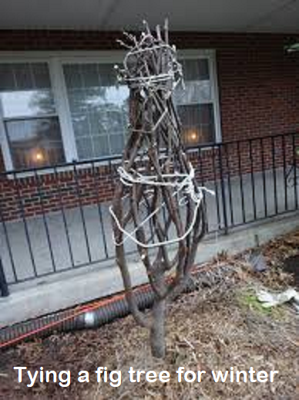In zones 5-6b you will need to protect your trees for winter. In late October when the leaves have fallen, some fig lovers will bury their trees in an almost ceremonial way. They remove any unripe fruit, prune the tree to remove or cut back branches that stick out too far, tie the branches close to the trunk, cut roots on one side of the tree, bend it down as close to the ground as possible and pin it down with ropes and stakes. Old carpets are used to cover the tree followed by plastic sheeting to keep the tree branches and the carpets dry. Old lumber, plywood and soil can be added to complete the burial.

Other growers are more inventive. They leave the tree upright but still do the pruning and branch tying. At this point an extension cord with an incandescent bulb at the bottom of an upright aluminum tube for heat can be enclosed with the tree. The TC2 Thermo Cube that controls the temperature is optional. It turns on at -7°C (20°F) and turns off at -1°C (30°F). Fig trees are hardy to about -11°C (-12°F). To save energy, the light only needs to be turned on when the temperature is predicted to go colder than this. It is still important to keep the branches dry, so carpeting can be used to cover the upright tree or blankets, followed by plastic tarp and tape to keep out water. Mulch the roots well with leaves or wood chips.

When spring comes with warmer weather of mid to late April, the covering can be removed.

For more information on fig care visit Penn University fig information site at: <https://extension.psu.edu/winterizing-your-fig-tree>